HAZL Sectioned Part List

Created by: Benjamin Richards | Updated: 04/15/2025

## Sections of HAZL

*This section contains how HAZL is split-up among different subassemblies in correlation to where they are on the drilling rig. HAZL is sectioned in cardinal directions.*

* Q1 - Northeast
* Q2 - Northwest
* Q3 - Southwest
* 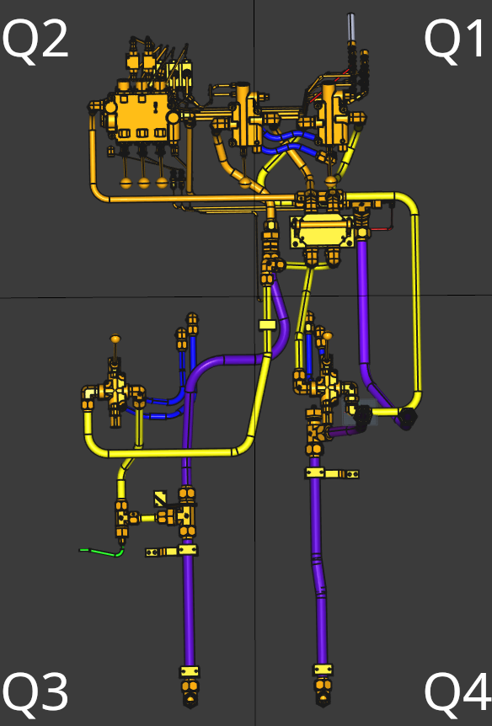Q4 - Southeast

## Section Q1

### Subassemblies:

* Q1 Splitter Valve (LS-3000-6)
* Q1 Handlebar Valves
* Q1 Hydraulic Group attached to Tower
* Q1 Underneath Handlebars
* Q1 Underneath Handlebars and Splitter Valve
* Q1 Down Hoses (Between Q1 Handlebar Valves & Q1 Splitter Valve)
* Q1 Bottom Section
* Q1 Middle Section
* Q1 Top Section

## Section Q2

### Subassemblies:

* Q2 Counterbalance Valve
* Q2 All Cylinders Valve
* Q2 3-Way Ball Valves
* Splitter Valve (LS-3000-6)
* Q2 House Attachments next to Counterbalance Valve
* Q2 Dial Hoses near Control Valve
* Q2 Next to All Cylinders Valve

## 

## 

## 

## 

## Section Q3

### Subassemblies:

* Q3 Underneath Steering Control Valve (SDCF120TM184LS)
* Q3 Steering Control Valve (SDCF120TM184LS)
* Q3 Behind Steering Control Valve
* Q3 Left Intake

## Section Q4

### Subassemblies:

* Q4 Steering Control Valve (SDCF120TM184LS)
* Q4 Underneath Steering Control Valve (SDCF120TM184LS)
* Q4 Right Intake
* Q4 Behind Underneath Steering Control Valve
* Q4 Left Filter
* Q4 Right Filter

# Q1:

### Q1 Splitter Valve (LS-3000-6)

|  |  |  |
| --- | --- | --- |
| **Part Name** | **Part Number** | **Amount** |
| **Size 16-12 JIC To O-Ring Elbow Connector** | 6801-16-12 | 2 |
| **Size 16 JIC Tube Nut** | 0318-16 | 2 |
| **Size 16 JIC Tube Sleeve** | 0319-16 | 2 |
| **Size 16 Tubing** | 1002 | 1 |
| **Size 16 Tubing** | 1003 | 1 |
| **Size 12-10 JIC To O-Ring Connector** | 6400-12-10 | 2 |
| **Hose Crimps** | XLT915-0N0006-0-A001 | 2 |

|  |  |  |
| --- | --- | --- |
| Q1 2 3-Way Ball Valve(s) (DE3L-16SAE) | | |
| **Part Name** | **Part Number** | **Amount** |
| **Handle** | exlterraHandle | 2 |
| **Handlebar Sleeve** | exlterraHandlebarSleeve | 1 |
| **Size 16 JIC To O-Ring 45 Degree Elbow** | 6802-16-16 | 2 |
| **16 JIC O-Ring Elbow 90 Degree** | 6801-16-16 | 2 |
| **Size 16 JIC Tube Nut** | 0318-16 | 6 |
| **Size 16 JIC Tube Sleeve** | 0319-16 | 6 |
| **Size 16 JIC To O-Ring Connector** | 6400-16-16 | 2 |
| **Top Metal Plate Protector** | XLT916-0K0029-A | 1 |
| **Bottom Metal Plate Protector** | XLT916-0K0030-0-A | 1 |
| **0.5” Nut** | Nylon_Nut_0.5in001 | 2 |
| **Size 16 Tubing** | 1013 | 1 |
| **Size 16 Tubing** | 1001 | 2 |
| **Size 16 Tubing** | 1008 | 1 |
| **Size 16 Tubing** | 1002 | 1 |
| **Size 16 Tubing** | 1004 | 1 |

|  |  |  |
| --- | --- | --- |
| Q1 Hydraulic Group | | |
| **Part Name** | **Part Number** | **Amount** |
| **Size 6 JIC Swivel Nut Elbow** | 6500-6-6 | 2 |
| **Size 6 JIC Tube Nut** | 0318-6 | 2 |
| **Size 6 JIC Tube Sleeve** | 0319-6 | 2 |
| **Size 6 JIC Bulkhead Union 45 Degree Elbow** | 2702-6-6 | 2 |
| **Size 6 Steel Bulkhead Fitting** | 0306-6 | 2 |
| **Size 6 (0.375") Crimp On Fitting** | 06G-06FJX | 2 |
| **Size 4 JIC Swivel Nut Elbow** | 6500-4-4 | 2 |
| **Size 4 JIC Tube Nut** | 0318-4 | 5 |
| **Size 4 JIC Tube Sleeve** | 0319-4 | 5 |
| **Size 4 JIC Swivel 45 Degree Elbow** | 6502-4-4 | 2 |
| **Size 4 JIC Bulkhead Union 45 Degree Elbow** | 2702-4-4 | 5 |
| **Size 6 Steel Bulkhead Fitting** | 0306-4 | 5 |
| **Size 4 (0.25") Crimp On Fitting** | 04G-04FJX | 5 |
| **Size 4 Tubing** | 1049 | 1 |

